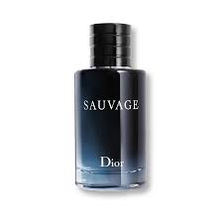

Dior PERFUME
Product Overview
Dior’s Women’s fragrance is designed for modern elegance and subtle sophistication. Its delicate floral and fruity notes create a fresh, feminine aroma perfect for daily wear or special occasions. Lightweight yet long-lasting, it enhances your presence with charm and grace.
Key Features
* Brand: Dior
* Category: Women
* Volume: 100ml
* Fragrance Type: Eau De Parfum
* Long-lasting performance (6–8 hours)
Pricing
Old Price: Rs. 2500
Discounted Price: Rs. 2250

